Study Tour 2017, Dept. of Finance
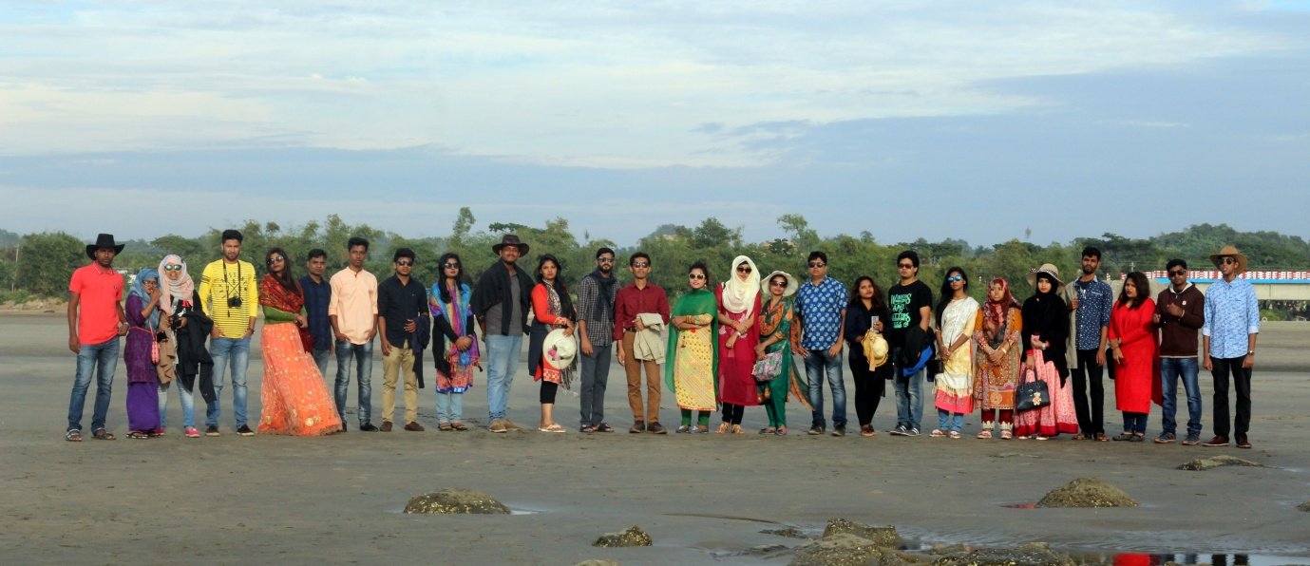

As a part of learning, students of 36th Intake of Department of Finance of Bangladesh University of Business and Technology (BUBT) have conducted a Study Tour and Excursion at Cox’s Bazar and Saint Martin during December 4-7, 2017. Students from 36th Intake along with two faculty members of the department attended the study tour enthusiastically.

