BANGLADESH UNIVERSITY OF BUSINESS AND TECHNOLOGY (BUBT)
Rupnagar, Mirpur-2, Dhaka-1216, Bangladesh
Phone: PABX-9024266, 9024277, 9015397, 9020132-4, Fax: 9024399
E-mail: info@bubt.edu.bd, Website: www.bubt.edu.bd



Notice for Admission in Summer Semester’2020

Admission in different Programs of Undergraduate and Graduate levels both Day and Evening shifts is going on with 50% waiver on admission fee for the Summer Semester’2020.
All Officers and Staff of Admission Office and other concerned are advised to follow and implement the above decision of the BUBT Authority regarding the admission fee of the Summer Semester’2020.

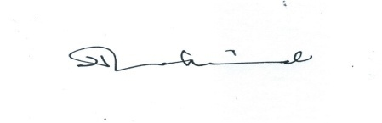
(Dr. Harun-or-Rashid)
Registrar
BUBT
Copy for distribution/necessary information:
1. P.S. to Vice Chancellor
2. Treasurer
3. Deans of all Faculties: Arts & Humanities/ Engineering & Applied Sciences/ Business/ Law
4. Chairmen of all Departments: Management/ Marketing/ Accounting/ Finance/ English/
Mathematics & Statistics/ Economics/ Law & Justice / CSE/ Textile Engineering/ EEE
5. All Faculty Members
6. Joint Registrar
7. Joint Director, Accounts
8. Assistant Registrar, Admission
9.BUBT Website
9. Office Copy

